**ANNEX V.3: BANK ACCOUNT NOTIFICATION FORM**



**ANNEX V.4: LEGAL ENTITY FILE (PRIVATE COMPANIES)**

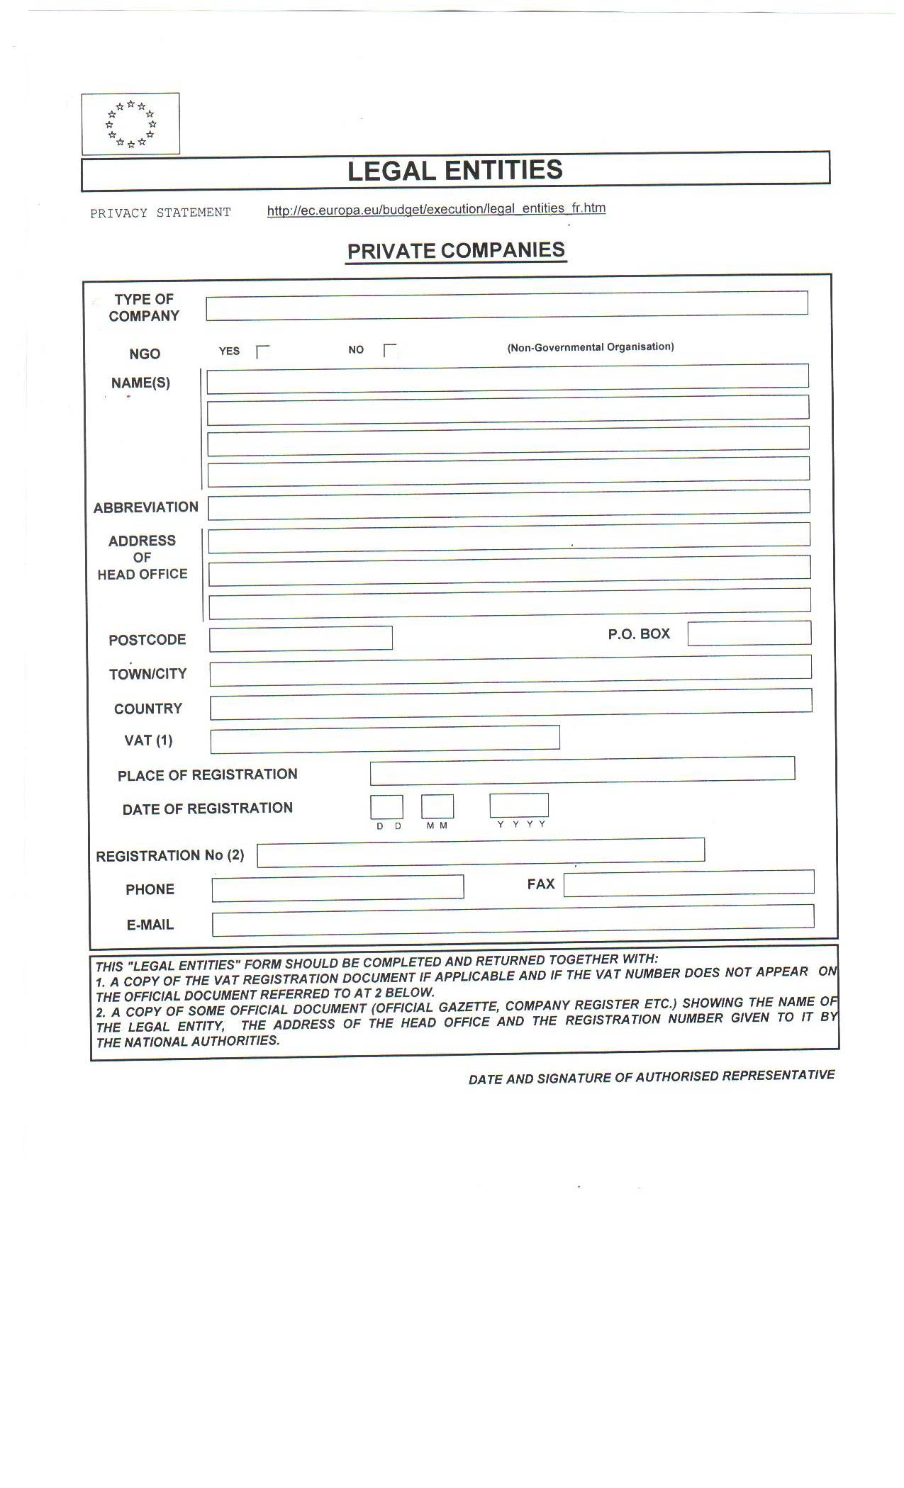

**ANNEX V.5: LEGAL ENTITY FILE (PUBLIC BODIES)**

